**CPSC 304 Project Cover Page**

Milestone #: 1

Date: 2024-07-12

Group Number: 18

| **Name** | **Student Number** | **CS Alias (Userid)** | **Preferred E-mail Address** |
| --- | --- | --- | --- |
| Charity Grey | 81808313 | s1i9f | charity.grey1@gmail.com |
| Marcus Guay | 57747115 | u2y6v | marcus.guay.99@gmail.com |
| Sarah Yu | 77021384 | l0t3a | sarahjxyu07@gmail.com |

By typing our names and student numbers in the above table, we certify that the work in the attached assignment was performed solely by those whose names and student IDs are included above. (In the case of Project Milestone 0, the main purpose of this page is for you to let us know your e-mail address, and then let us assign you to a TA for your project supervisor.)

In addition, we indicate that we are fully aware of the rules and consequences of plagiarism, as set forth by the Department of Computer Science and the University of British Columbia.

**2pts Proposal included clear and satisfactory answers to all of the questions**

1. **What is the domain of the application? Describe it**.

The domain of our application will be file system version control. File system version control is about keeping track of what, how and in which order/which combination of files were changed over time, as well as any folders, insertions, deletions and also making identifying important versions of the file system easier.

1. **What aspects of the domain are modeled by the database?**

The aspects of the domain that will be modeled by the databases will be who works on the files, who made committed changes to the files, as well as the who added/deleted files from the current version, as well as which files are in which folders and who is allowed to made changes to this file system, called the repository.

**Database specifications: (3-5 sentences) What functionality will the database provide?** *I.e., what kinds of things will people using the database be able to do?*

Users can view files committed on different branches in a repository they have access to, and they will also be able to view the folders structure of their file system.

If they have the appropriate permissions for the following actions, they will be able to:

1. make edits to these files
2. insert files
3. delete files
4. commit their changes to the file system into the database and add comments to those commits
5. revert to a previous change

**Description of the application platform: (2-3 sentences) 1 pts Proposal adequately described the platform or stack**

We will use the Oracle DBMS to store the schema as well as host the instances of the schema for the relational database. We will also be adding rows into those instances via the Oracle API.

*What database will your project use (department provided Oracle, MySQL, etc.)?*

*See the “Project Platforms” section of this document for more information.*

***b. What is your expected application technology stack (i.e., what programming languages and libraries do you want to use)? See the “Project Platforms” section of this document for more information.***

We will write our own JavaScript in Node.js to connect and serve our web application on the remote ubc server. We will have Node.js calling and receiving requests to and from our Oracle DBMS.

We also wish to use HTML, CSS, Javascript, Tailwind.css (potentially), and React for the frontend of the web application.

**An ER diagram for the database**

*Please limit your diagram to a letter size page (8.5 x 11 inches).*

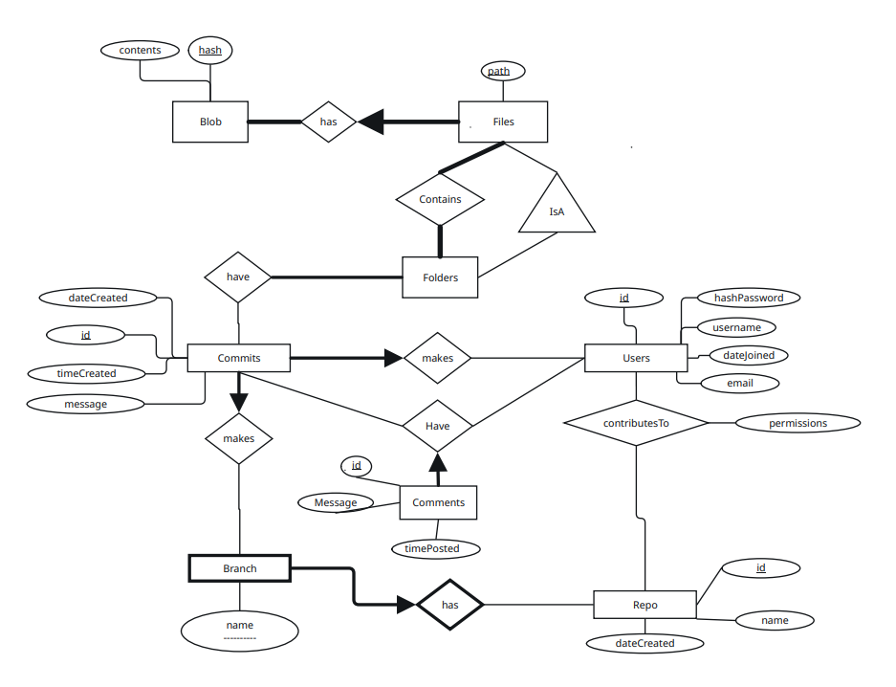

*Your ER diagram must use the conventions from the textbook and the lectures*

*ER DIAGRAM REQUIREMENTS:*

* *7 ENTITIES + 7 NON-ISA/WEAK ENTITY RELATIONSHIPS*
* *At least one meaningful ISA relationship*
* *All entities must have their keys*
* *roAt least one meaningful (non-trivial) weak entity; or replace with it with one more meaningful ISA relationship*